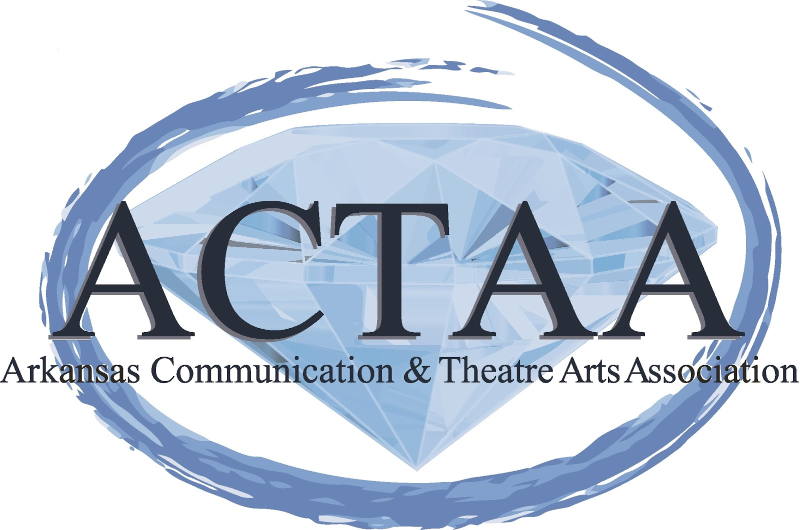
Arkansas Communication and Theatre Arts Association
Fall Conference
September 5th, 6th, & 7th, 2019
Marriott Hotel in Downtown Little Rock
AS OF 5/10/19
Date | Time | Location | Workshop | Presenter
Thursday  September 5th | 3:30-4:30pm | Petit Jean Meeting Room | Early Registration/Vendor set-up | Jannetta Carney  Russellville High School
 | 4:30-9:30pm | CC Level 2 | Exhibits/Vendors
 | 4:00-5:30pm |  | Committee Meetings
 | 5:00 – 8:30 p.m. | Off-site | Executive Council Dinner: held at La Terraza:  3000 Kavanaugh Blvd  Little Rock, Arkansas 72205
 | 6:30-8:00pm | Chicot/Grampas Room | PD #1:
 | 8:00-8:15pm |  | BREAK
 | 8:15-9:45pm | Chicot/Grampas Room | PD#2: Living your Alter Ego:  In this session, Jannetta tells how she discovered her Alter Ego, Goggle Girl and how GG has been an inspiration to many, including herself, to get off the couch, live your life, and reach for what you want your life to be. If you want to know how to let go of the negative and reach your potential, this session is for you. Find how to be happy with every aspect of your life and be the best you can for others.
Friday  September 6th | 8:30-9:30 a.m. | Petit Jean Foyer | Registration
 | 8:30-9:30 am | Riverview Meeting Room | New Member/ Mentor Breakfast
 | 9:30 – 11:30 a.m. | Conway Lecture Hall | PD #3: You've Got to Nourish to Flourish: Why are you in the business of education? What brought you here and what keeps you here? We will look at ways to design our personal and professional lives to help manage the stress which naturally comes along with being a working adult. I am excited to partner with you in this journey to finding your purpose, highlighting your gifts, and reconnecting you to your greatness. | Amber Pirnique  Cabot High School  OPENING COMMENTS by Brandon Box-Higdem  Bentonville High School
 | 11:30 – 11:45 a.m. |  | BREAK
 | 11:45 – 1:45p.m. | Conway Lecture Hall | PD#4: Breaking Down Our Walls:  This experience is all about being able to see the person behind the masque. We all have daily struggles that we deal with work, home, and extracurricular involvements, but how often do we take the moment to recognize that in others? In Breaking Down the Walls, we will address how knowing a person’s story helps in shaping our perspective and helps in our interactions with that person. This workshop will help us to be the best AACTA members that we can while also creating the best teachers. In participating in this workshop, you will be able to take practical means back to your students to help bridge the gap between groups. | Graci Johnson  Bentonville West High School  Julia Howell  Bentonville West High School  Laurie Harrison  Fulbright Jr. High School
 | 1:45 – 3:30 p.m. | DOWNTOWN!!!!!!!!!!! | Lunch On Your Own
 | 1:45 – 3:30 p.m. | Petit Jean Meeting Room | Executive Council Meeting/ Review Committee Reports
 | 3:30 – 5:30p.m. | Conway Lecture Hall | High School Meeting | Joel Brown, facilitator
 | 3:30 – 5:30p.m. | Petit Jean Meeting Room | College Meeting | John Gale, facilitator
 | 3:30 – 5:30p.m. | Grampas | Retired/Lifetime member meeting | Pat Treadway, facilitator
 | 3:30 – 5:30p.m. | Chicot | Junior High Meeting | Ron Spalter, facilitator
 | 5:30-7:00pm | Riverview Meeting Room | Dinner and Speaker/ PD  Meal Provided in Cost | Jane Morgan-Balgavy-Speaker  Cabot High School
 | 7:15-8:45pm | Chicot | PD#5: Conscious Discipline  This session focuses on you, the educator, and your need for self-care!!! You’ll learn about the different brain states. With this awareness, we learn to consciously manage our own thoughts and emotions so we can help others do the same. We’ll be interactive and implement strategies from Conscious Discipline in our session. Come see how CD can help you be the best version of you! | Ron Spalter  HarBer High School 8-9  Afton Schleiff  HarBer High School 8-9
 | 7:15-8:45pm | Grampas | PD#6: Basic Argumentation for any classroom  Lessons that utilize argumentation are accessible to any educator, and introducing debate to your curriculum or classroom does not have to be scary! This interactive session will provide attendees with lesson plans and activities that are adaptable for any classroom regardless of grade level, skill level, content knowledge, or subject. | Rosie Valdez-Block  Little Rock Central High School/ ACTAA President
 | 8:45-10:00pm | Chicot/Grampas | PD #7: EVERYDAY PEACEMAKING: MANAGING THE CONFLICTS THAT DISRUPT OUR CLASSROOMS  Because no two individuals have exactly the same expectations and desires, conflict is a natural part of our interactions with others. How we handle conflict, defines our relationships and position with students and colleagues. Understanding different modes of responding to conflict and reflecting how we naturally respond can assist us to best understanding how to engage with others to resolve conflict ethically and professionally. This session will explore the Thomas-Kilmann Conflict Mode Instrument (TKI), the five modes of conflict management, and a personal assessment of how different conflict-handling styles affect personal and group dynamics and for learning how to select the most appropriate style for a given situation, whether a student or professional interaction. Each participant is asked to complete the TKI Assessment, linked below, 24-hours in advance of the session to be provided a personal assessment guide during the session. http://select.asub.edu/TakeSurvey.aspx?PageNumber=1&SurveyID=n23K3m2 | Zack Tucker  ASU Beebe  ACTAA 2nd Vice President Elect Elect
 | 10:15pm-until | Fassler Hall  Address: 311 East Capitol Ave.  More info: www.fasslerhall.com/locations/little-rock | ACTAA Get Together:  A chance for us to unwind and relax!!!! Outdoor patio, beer, food, pool, outdoor games and great conversation!
Saturday, September 7th | 9:00-9:30 am | Petit Jean Foyer | Registration
 | 8:00-9:30am | Chicot/Grampas | PD #8: The Evolution of Oral Communication in the Classroom:  In 2018 the ADE began looking for an evidence based approach to inquiry that could be used to support school districts across the state in the transformation of education. Marzano’s High Reliability Schools framework met the criteria. In January of 2019, every superintendent and principal in the state received High Reliability Schools (HRS) resources. Maybe they’ve shared it with you. Maybe you don’t know anything about it. Maybe you want to know more. In this session Leigh-Alyson Walters will share her experience with implementation of various parts of the High Reliability Schools framework in her communications classes. She will share how her department selected priority standards, created proficiency scales, involved students in various processes, structured lessons and also answer questions from interested colleagues. http://www.arkansased.gov/divisions/special-projects/high-reliability-schools-hrs-in-arkansas | Leigh Walters  Hall High School  Ta-Neisha Marshall  Bentonville West High School
 | 9:30am-12:30pm | Conway Lecture Hall | ACTAA General Meeting | Executive Council
 | 9:00-10:30 am  (For our New members) | Chicot | PD#9: Where Inspiration Lead Me: Costume Design, Drama Class & Life  This session will present (and request your input on) strategies for creating a family in the theatre tech classroom through valuing kindness, creativity, and autonomy. We will discuss best practices that have been successful in creating an inspirational space for our kids. Finally, we will explore the positive classroom benefits of self care and pursuing your own personal passions to share with your students. | Shelle House  North Little Rock High School
 | 10:45-12:15pm  (For our New members) | Chicot | PD #10: Dance Inspires!  This session will explore why people dance, what inspires us to dance, inspirational classroom movement lessons for non-dance instructors, and what to do when you experience burnout as a choreographer. | Christen Pitts  North Little Rock High School  Liz White  Rogers High School
 | 12:45-2:00pm | Riverview Meeting Room | Awards Luncheon and Guest Speaker/ PD  Meal Provided in Cost | Anthony Clark-Kaczmarek, Speaker  Alice Buffett Arts Magnet School, Omaha, Nebraska
 | 2:00-4:00pm | Petit Jean Meeting Room | Executive Council Meeting

