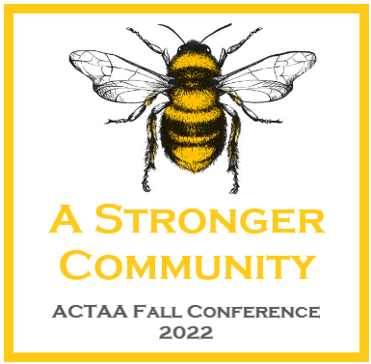
GREETINGS, ACTAA members!!!
LET’S TRY THIS AGAIN!!!

ARE YOU READY????
With the AR legislature passing a bill to regulate school start time, it really threw us for a loop! Some schools begin August 15th and some begin on the 22nd. We have made a shift and hope this works for you all. We are going to convene in Bentonville, Arkansas this Friday, August 26th thru Sunday, August 28th at the Double Tree Hotel!!!! It is a Friday eve through Sunday at noon, in order to get you all on the road and back with some breathing time before we begin school again on Monday. Cool aspect of this is we were able to add MORE food!!!!! YESSSSSS!!!!!

Fall conference this year is SUPER important that we get as many members there to participate. We are covering issues that are detrimental to our entire organization and need your feedback and input. In the end the results will be building a stronger sense of community within the ACTAA organization and reconnecting the heart and soul back to your teaching career. We have a large amount of phenomenal experiences planned for you to join in, including presenters from the Arkansas State University Diversity and Equity department and Theatre Squared. We are looking forward to being back in a face-to-face setting, reconnecting with colleagues and tapping back into why we chose education in the first place. We will also begin to look at branding and why that topic is so important for today’s educators to think about and how to put yourself out there…not only for your own students but also for professionals in general. We have opportunities for professional development across ALL our curriculums.
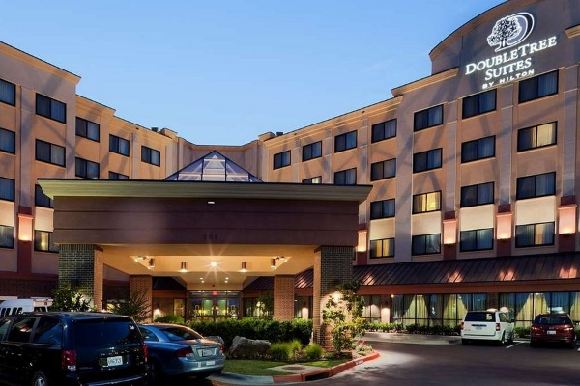
Hotel Rooms are $129 a night and can be reserved NOW!!!! Please call the reservation line through the Double Tree to reserve your room at 1-800-222-TREE. Please remind them that your room is under the block “ACTAA Fall Conference”. You will need to provide a credit card to guarantee your room reservation. The room block is on hold until August 13th, 2021. After that time, rooms will be on a space available basis.

Fall Conference 2022 Registration Fees
Early Bird total (by August 13th)
$185 per person.
From August 14 to August 20th:
$225 per person
August 21st to August 25th :
$275 per person
Day of Registration:
$330 per person
If you choose to attend one Single Day only
Cost Early = $125
versus
Day of Registration = $250
We welcome guests, however must let the hotel know ahead of time:
Guest Meals: Saturday Eve Dinner $50 per guest/Saturday Lunch would $25 per guest/ Sunday Breakfast will be $25 per guest

PLEASE NOTE: If you struggle with having to cover conference yourself and are unsupported by your district, we want you with us! Please reach out and we can figure out a scholarship situation to get you covered.

Please take a moment and fill out this Google Form to let us know your meal attendance intentions so that we can provide the hotel with realistic numbers for our event. ALSO, on this form are some important questions we will dig into during conference.
https://forms.gle/PFLCDPJSFmrQ6G2s6

NOTE FOR ALL: If you register and are unable to attend, you must cancel by August 13th (the hotel block opens to the public on the 14th) otherwise, you will forfeit all your registration fees. Cancelling after August 13th, your fees are non-refundable.

It is going to be a weekend filled with good things…not only for your soul, but also for us as an organization, along with all our business we also must get accomplished that weekend. We will come together for wonderful food, fellowship, and will have motivational keynote speakers meant to entertain and build you up, which is so important. Schedules are being finalized as we speak, but hope to see you all there!!

SEE YOU IN Bentonville this fall!!!!!

Sincerely,
Brandon Box-Higdem
ACTAA President

